

**RANCH MANUAL**

**(Revised June 2022 by: Pepper Martin)**

TABLE OF CONTENTS

Pre-Ranch Priorities . . . . . . . . . . . . . . . . . . . . . . . . . . . . . . . .

**Responsibility: Ranch Content Officer(RCO) Ranch Logistics Officer(RLO)**

**National Responsibilities(NAT)**

Beginning Early Fall

1. Sign Contract with Host Site and Host Site Needs with new dates**(NAT)**
2. Book Hall’s Cabin again or the HAWC retreat and week of Ranch**(RLO)**
3. Set-Up Registration and process with Katie Davish (new spreadsheet link)**(RLO)**
4. Communicate with Fidelis on thier cabin/bunk needs. Aggreement made.**(RLO)**
5. Promote and Communicate Ranch to chapters via video promos.**(NAT) & (RCO)**
6. Communicate with Commanders regarding Registration**(NAT)**
7. Determine Theme and Marketing Material**(RCO) & (NAT)**
8. Find Seminarians and Priests**(RCO) & (NAT)**
9. Establish who the Ranch Logistics and Ranch Content officers are, as well as Music Leader, Photographer, and AV person.**(NAT)**
10. Establish Ranch Nurse/Doctor**(RLO)**

Beginning Early Spring

1. Rent Electronic Equipment**(RCO)**
2. Rent Golf Cars from T&T Golf Cars (4 for us) – (3 for Fidelis) We bill Fidelis for this.**(RLO)**
3. Communicate to the Rafting company about dates and numbers, and contract for white water photographer to upload photos onto a shared drive **(RLO)**
4. First Aid Supplies and sports equipment purchased**(RLO)**
5. Fraternus Ranch Printed content to use in Assembly Hall**(RCO) & (NAT)**

After Registration deadline has passed

1. Assign bunks, activity groups, rafting times, warrior dash groups, and squads.**(RLO)**
2. Make master schedule, activity rotations, and chapter groups for each chapter for the number of captains they have. Printed and copied.**(RLO)**
3. Order T-shirts and print lists of chapters with sizes for distribution.**(RCO)(RLO)**
4. Ask Commanders to Bring all waivers for camp and whitewater rafting to be turned in to the Ranch logistics officer.**(NAT)(RLO)**

Ranch Priorities . . . . . . . . . . . . . . . . . . . . . . . . . . . . . . . . . . . .

1. A Typical Day at Ranch (What to Do and When)
2. Arrival and packet pickup.
3. Signature Ranch Events
4. Additional Events in Schedule
5. Sacraments
6. Content
7. Squad Time
8. Schedule Flexibility

Post-Ranch Priorities . . . . . . . . . . . . . . . . . . . . . . . . . . . . . . .

1. Surveys/SWOT Analysis **(NAT)(RLO)(RCO)**

Pre-Ranch Priorities

___________________________________________________

**Beginning Early Fall**

1. **Sign Contract with Host Site and Host Site Needs**

Contract is typically signed one year in advance and should include dates for both HAWC Retreat and Ranch. The host site should meet the following needs:

1. Housing
   1. Priests
   2. Seminarians
   3. Families
   4. Nurse/Medic Station
   5. Leadership Team
   6. Captains/Brothers
   7. Separate Bathrooms for Captains and Brothers
2. HAWC Retreat. Hall’s Cabin down the hill is booked separately for the HAWC Retreat.
3. Cabin space for Reposition of the Blessed Sacrament
4. Key Activities
   1. Paintball
   2. Whitewater Rafting
   3. Wave pool and water slides
   4. Adventure race
   5. Covered pavilion (new this year 2022)
5. Warrior Dash Space. We use the entire camp on day 3 to have the warrior dash.
   1. Eight stations are set up around camp so groups can earn points to determine a winner. There are 8 warrior dash groups.
6. Meeting Spaces
   1. Main Space with Stage/AV Hook-Up. Main Space should fit all Captains and Brothers during Ranch.
   2. Smaller meeting space for Captains to meet during school of prayer, while Brothers remain in Main Space.
7. Space for Writing Letters to Benefactors (Dining Hall Staff at Ocoee Ridge made extra sandwiches for chapters that requested them)
8. Place to serve as Medical and First Aid Area (Assembly Hall)
9. **Setup Registration *2022. I don’t know anything about this. This is handled on the national level.**

Accounts Needed:

*Cognito Forms*

Username: [josh@fraternus.net](mailto:josh@fraternus.net)

Password: 7Virtue$

*Zapier*

Username: [josh@fraternus.net](mailto:josh@fraternus.net)

Password: 7Virtues

Registration for Ranch is conducted via Cognito Forms.

1. Login to the account

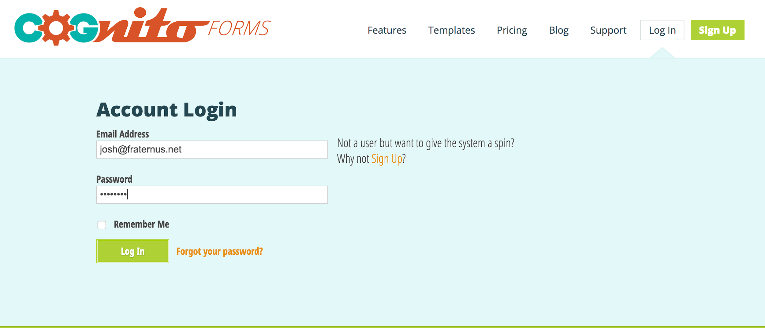

1. Find the form from last year, “Ranch Registration 2018”

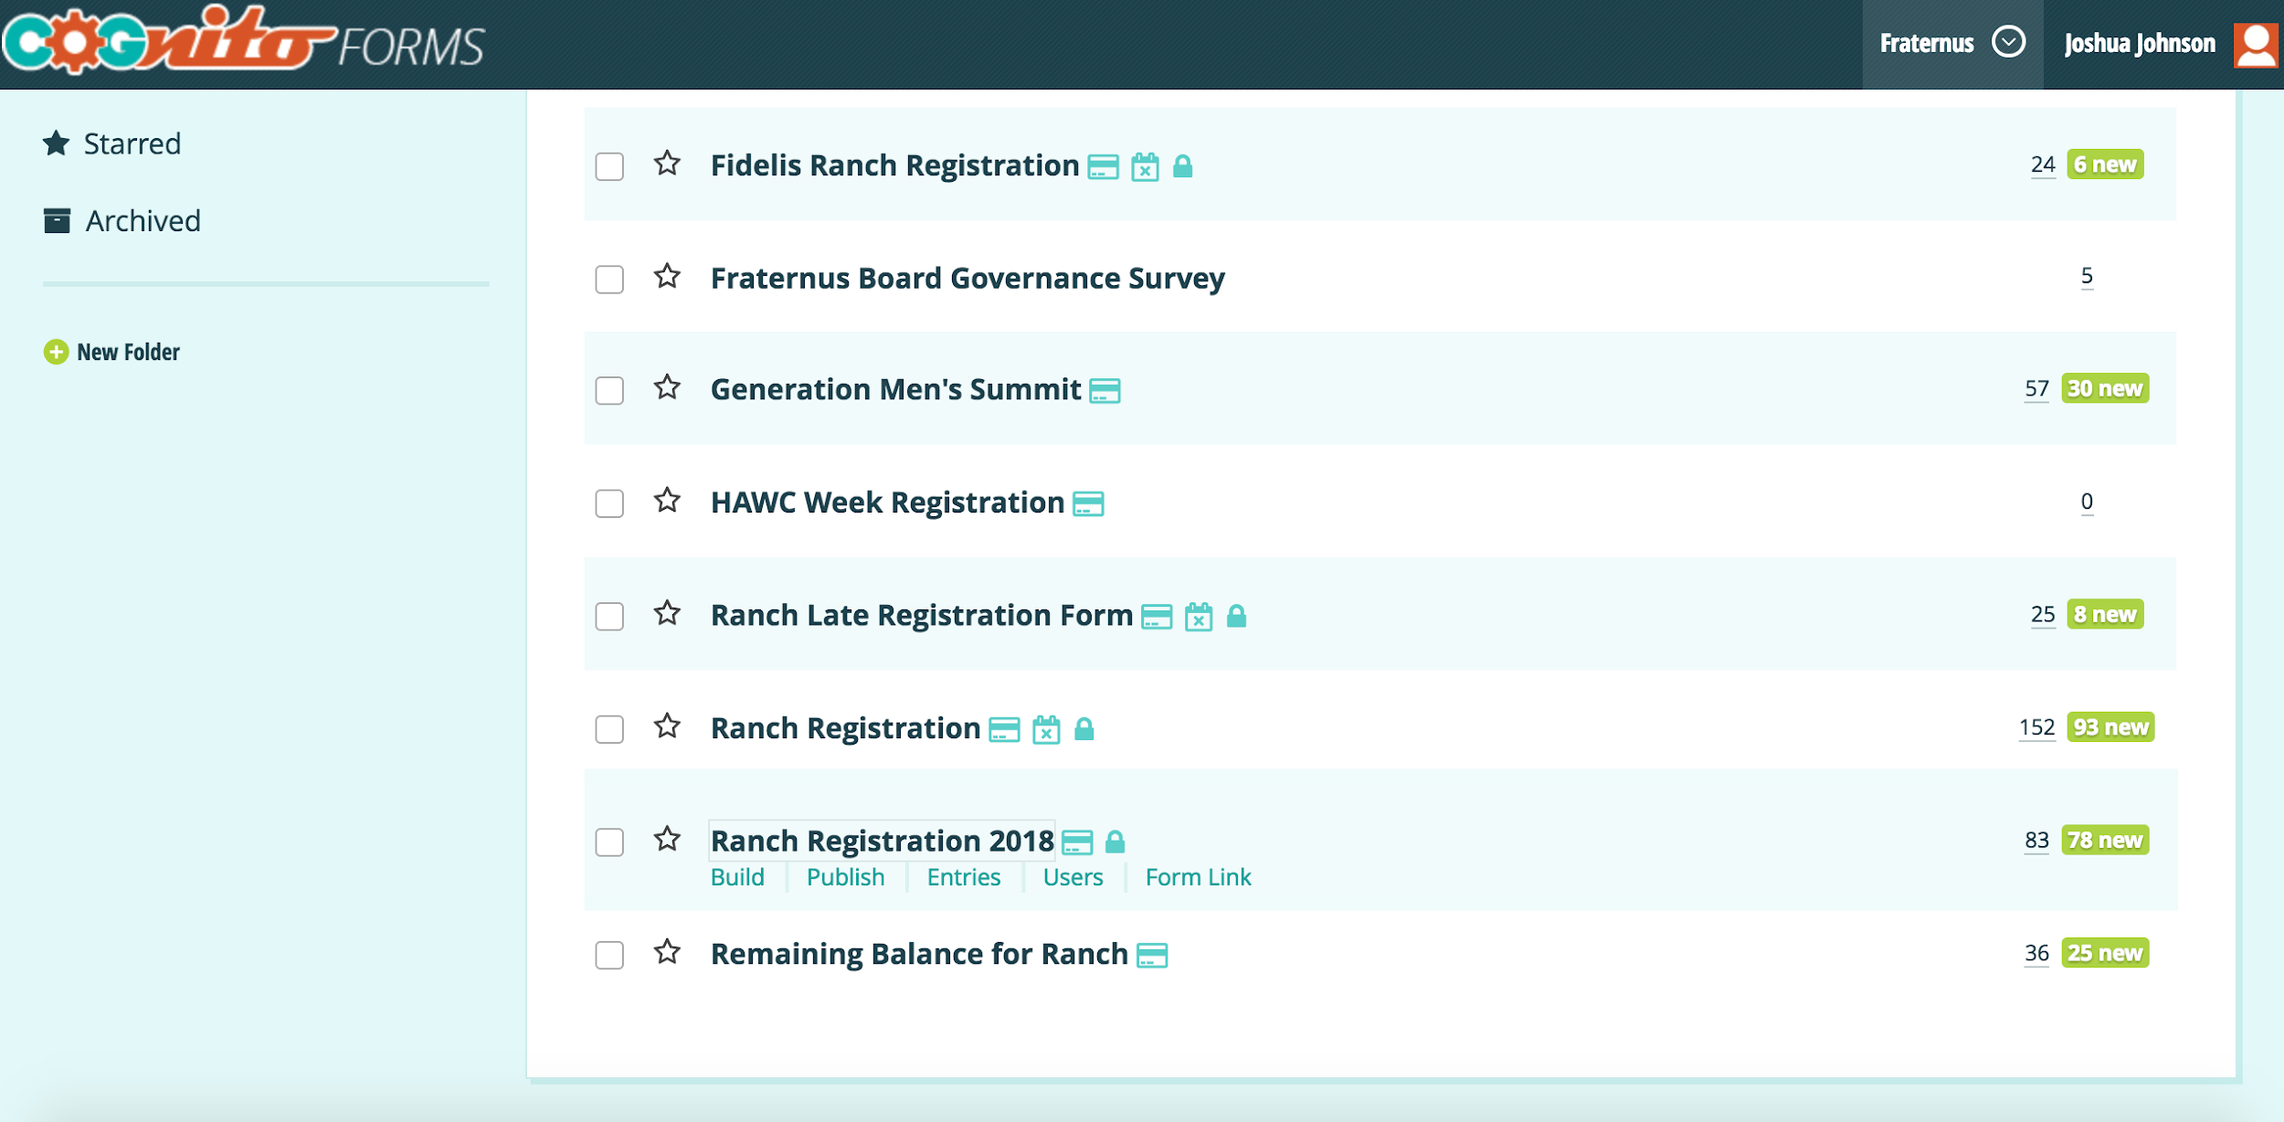

c. Under “Build” make all necessary changes to dates, cost, registration deadlines. Changes to the actual calculation of the registration fee are done under the “Boys Registration Fees” and “Adult Registration Fees” titles.

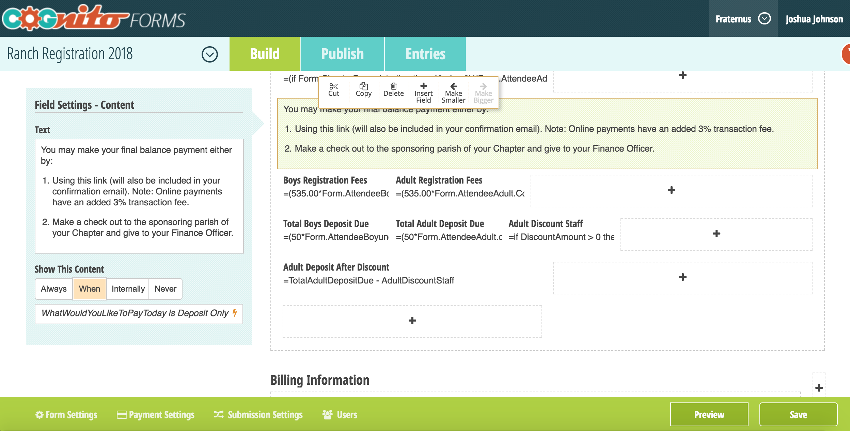

d. Be sure to “Save” after changes are complete.

e. Set up Zapier. Log in to the account.

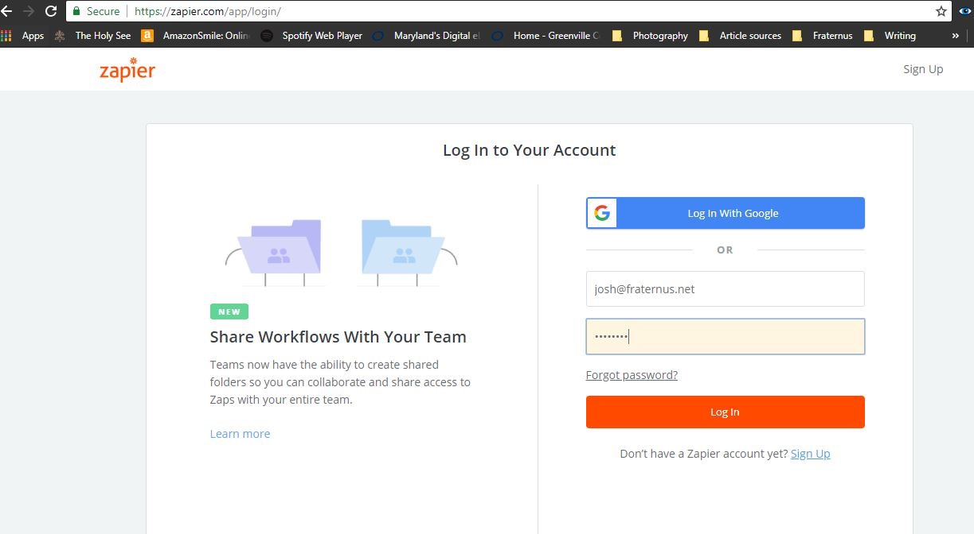

f. Go to “Zaps” tab and link the different Zaps.

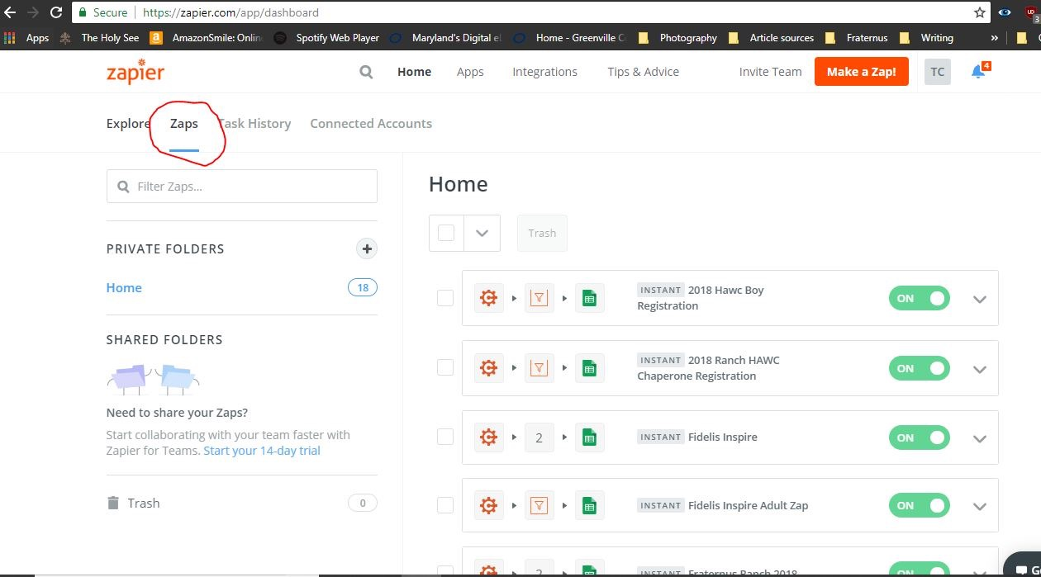

There are four distinct Zaps for Ranch registration. They take the information from the Cognito registration form and enter it in the master Google spreadsheet for Ranch, making a new row for each entry. The first enters the registration and billing information on the first tab “Ranch Registration” and enters the rows for the Brother registrations on the “AttendeeBoyUnder18DuringRanch” Tab.

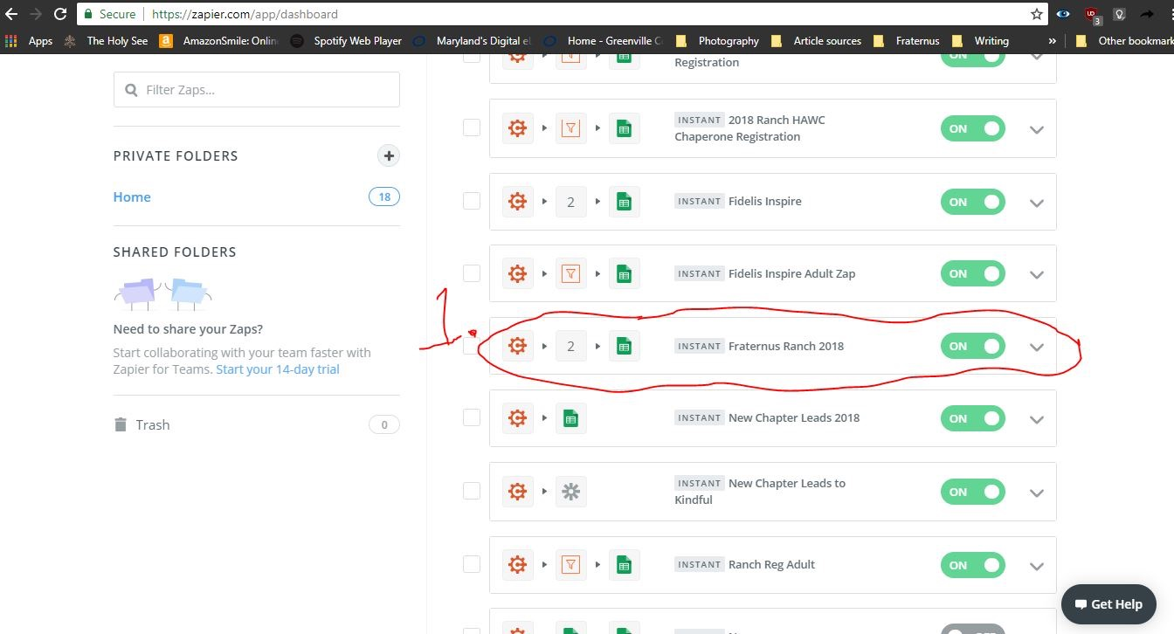

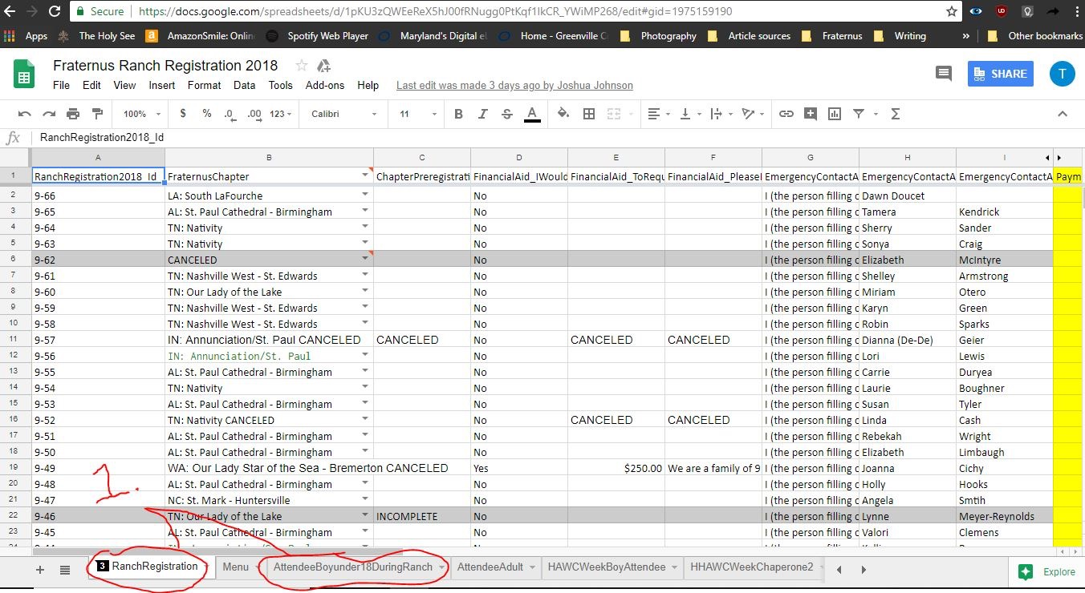

The other three link the Captain registrations, HAWC Brothers, and HAWC Adults to the Google spreadsheet, creating new rows for each new entry on the respective tabs.

g. Within each Zap you will have to set the trigger to correspond to the new form for this year.

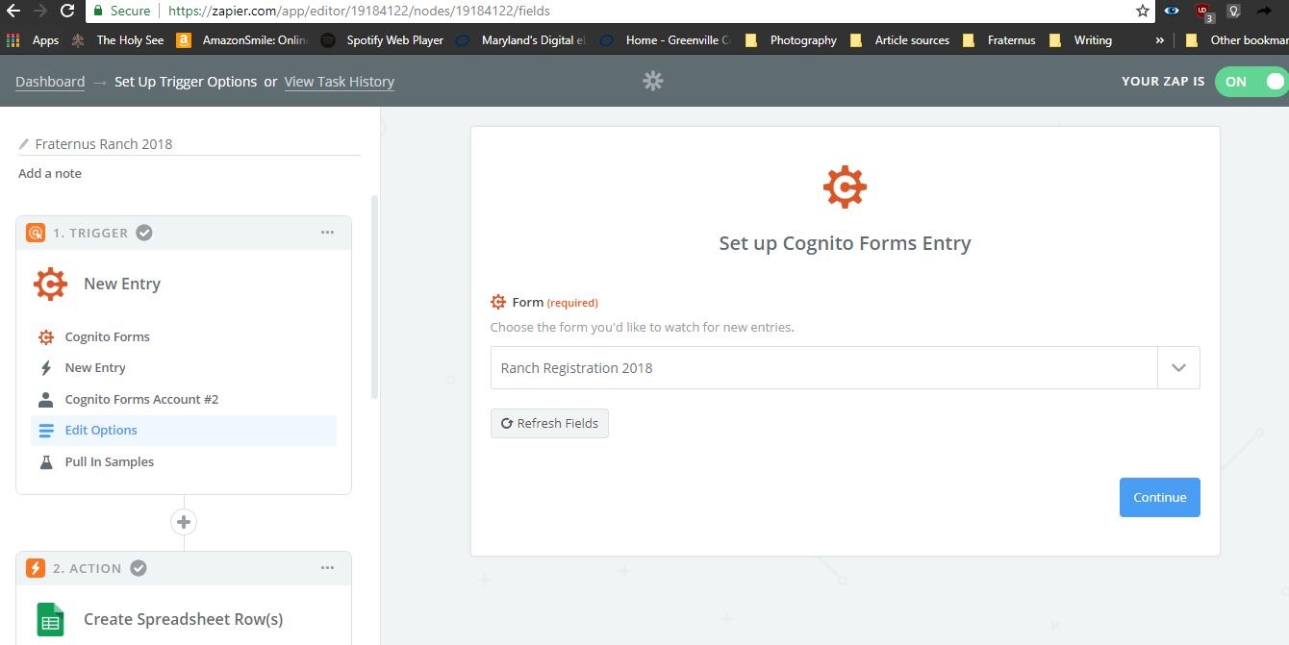

h. Then you will have to match all the fields in the form to their corresponding rows in the Google sheet.

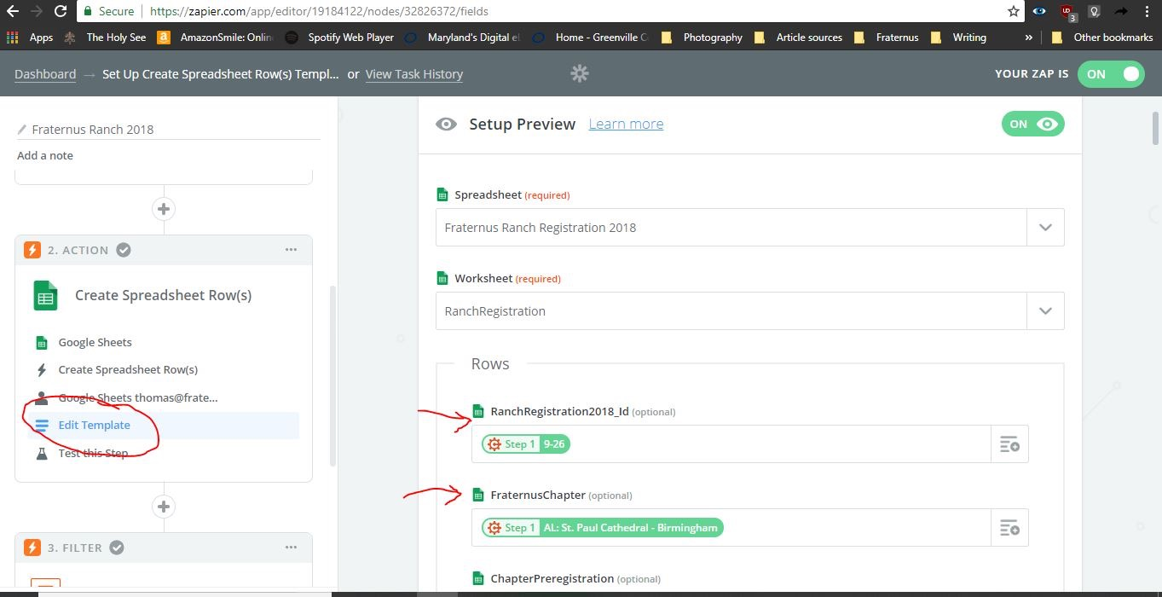

*Tip: It is useful to do a manual export from Cognito to an Excel spreadsheet and then use the headers from that spreadsheet to set up the one in Google Sheets, that way all the data corresponds exactly (for example, if a new field is added since last year it will fit in its proper place).

*Tip: To match all the data fields from Cognito to the corresponding rows in Google sheets it is helpful to have a completed test form that has all the fields filled out.

1. **Promote Registration**

Accounts Needed:

*MyEmma*

Username: [josh@fraternus.net](mailto:josh@fraternus.net)

Password: The7Virtues

*Vimeo*

Username: [info@fraternus.net](mailto:info@fraternus.net)

Password: 7virtue$

Most Ranch and HAWC Retreat promotion is done through MyEmma which is an email platform. Promotion videos are uploaded to Vimeo, as well as the Fraternus Ranch page and then linked to MyEmma emails.

**How to use MyEmma**

1. Login to MyEmma

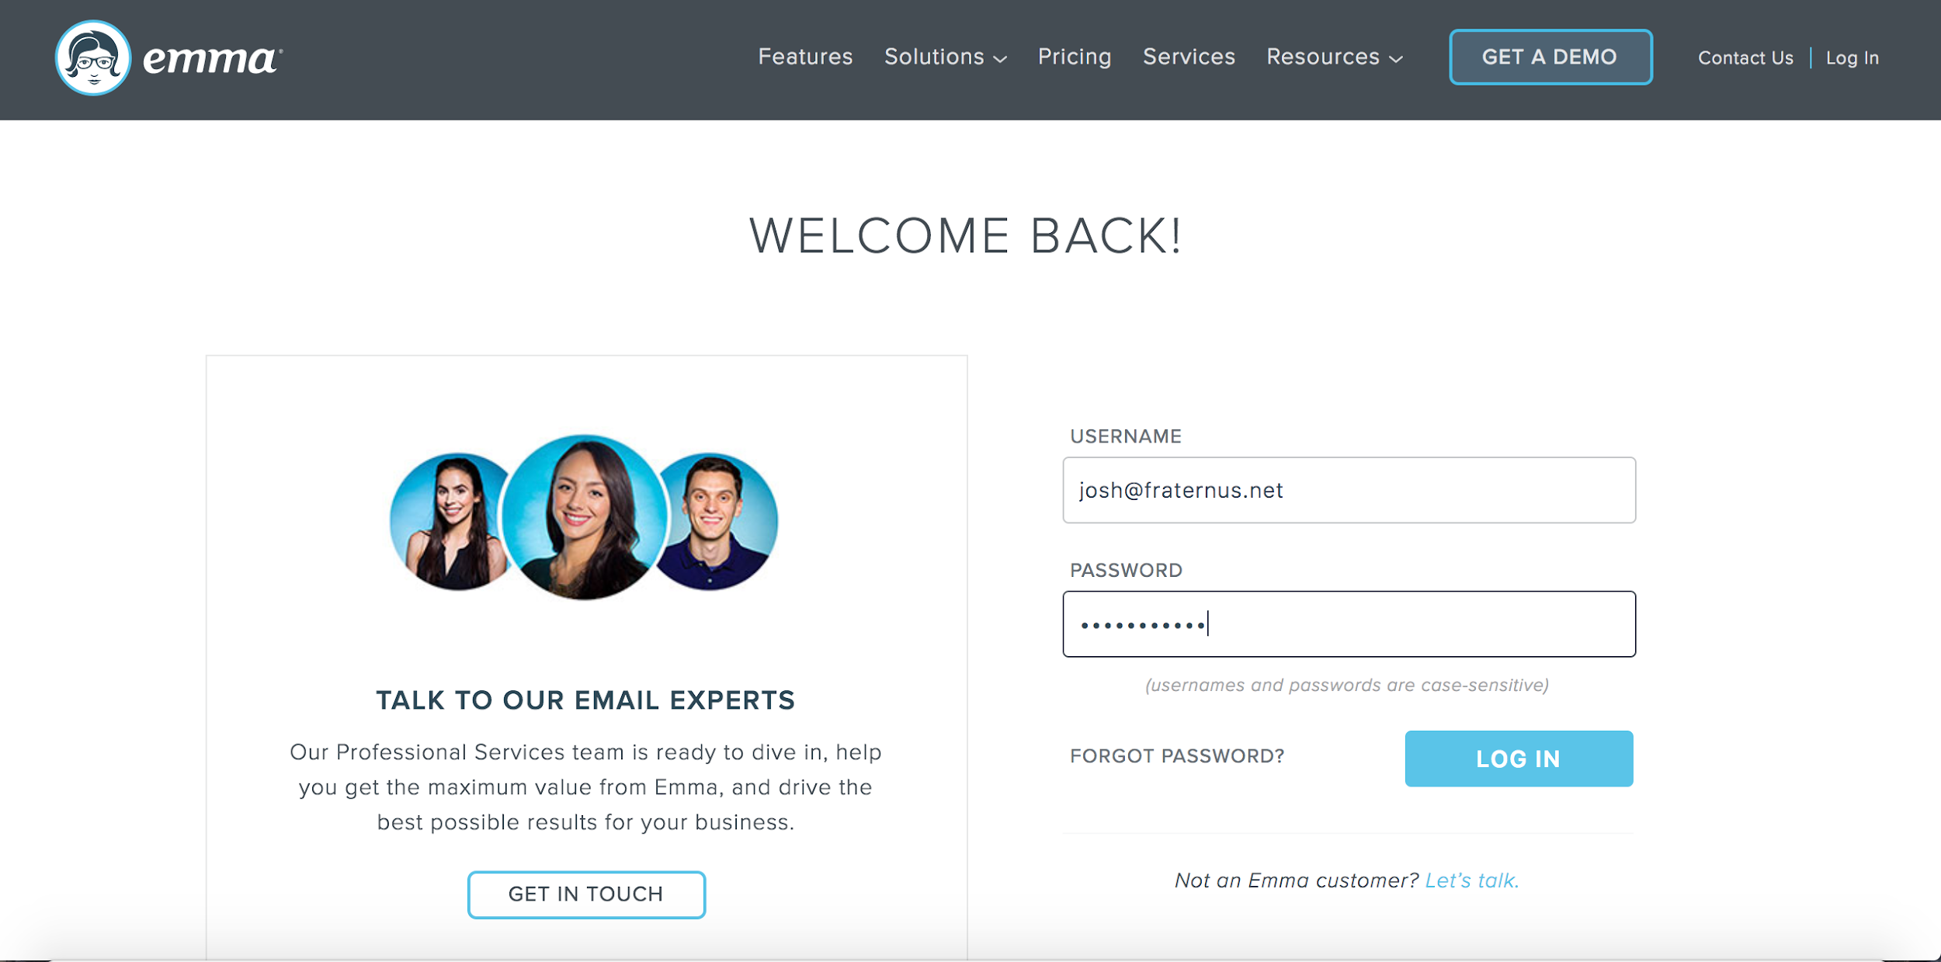

1. Select ‘Search for Account” and Select “Fraternus”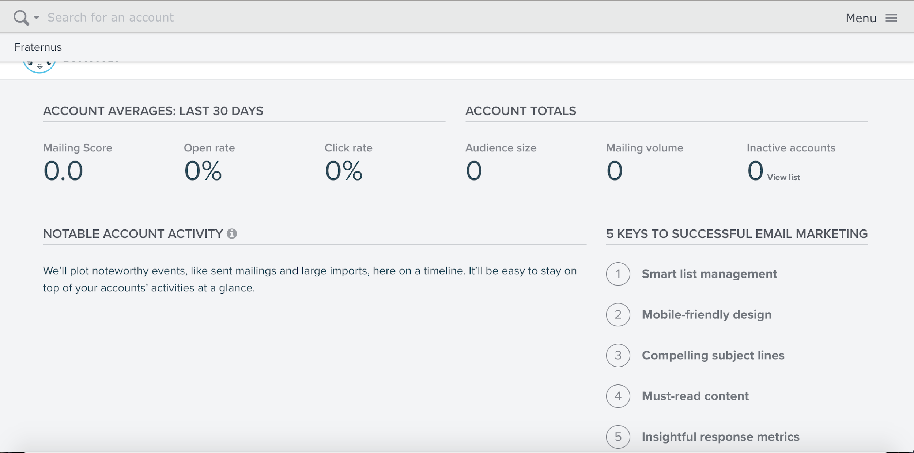
2. Select “Campaigns” in the top bar.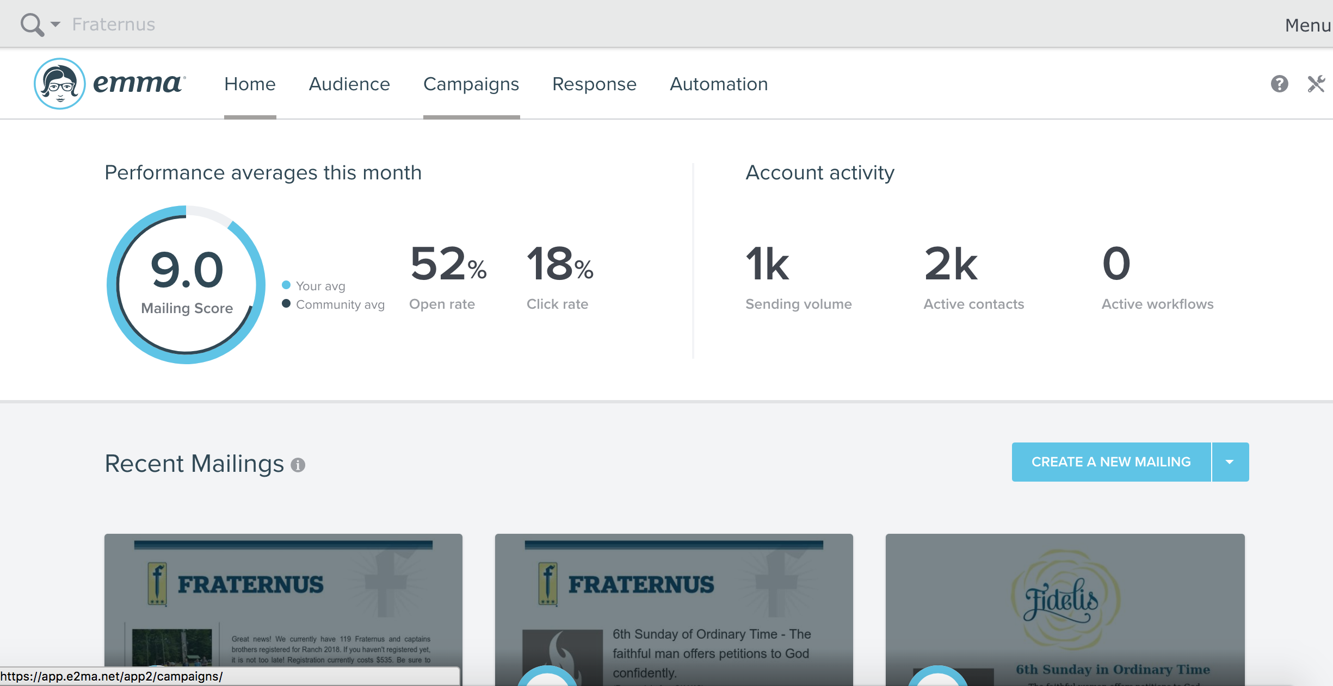
3. Select “Sent” and search for the last email that was sent regarding Ranch, duplicate this email, and use it as a template for your email .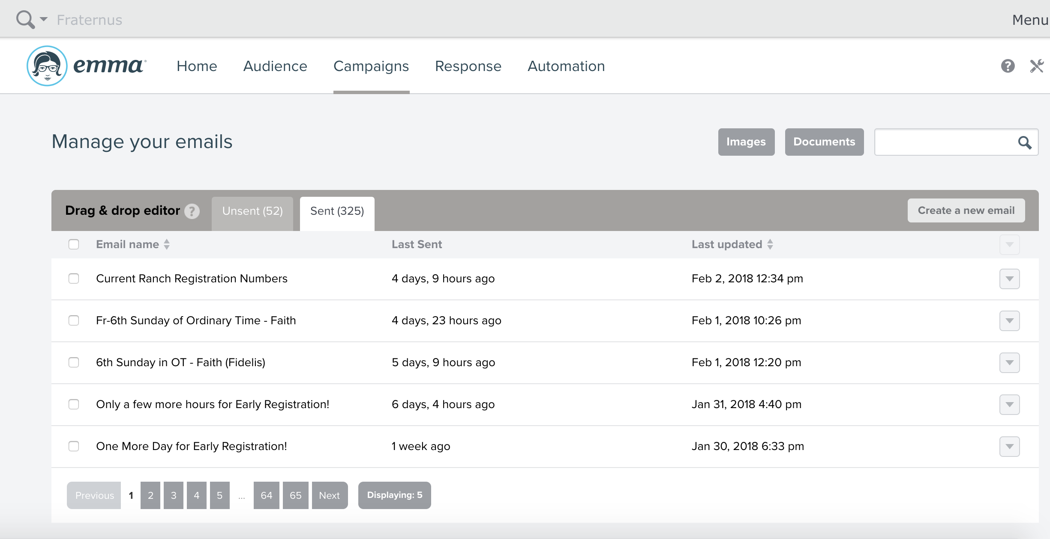
4. Click on the dropdown menu to the right of the email and select “Copy this mailing”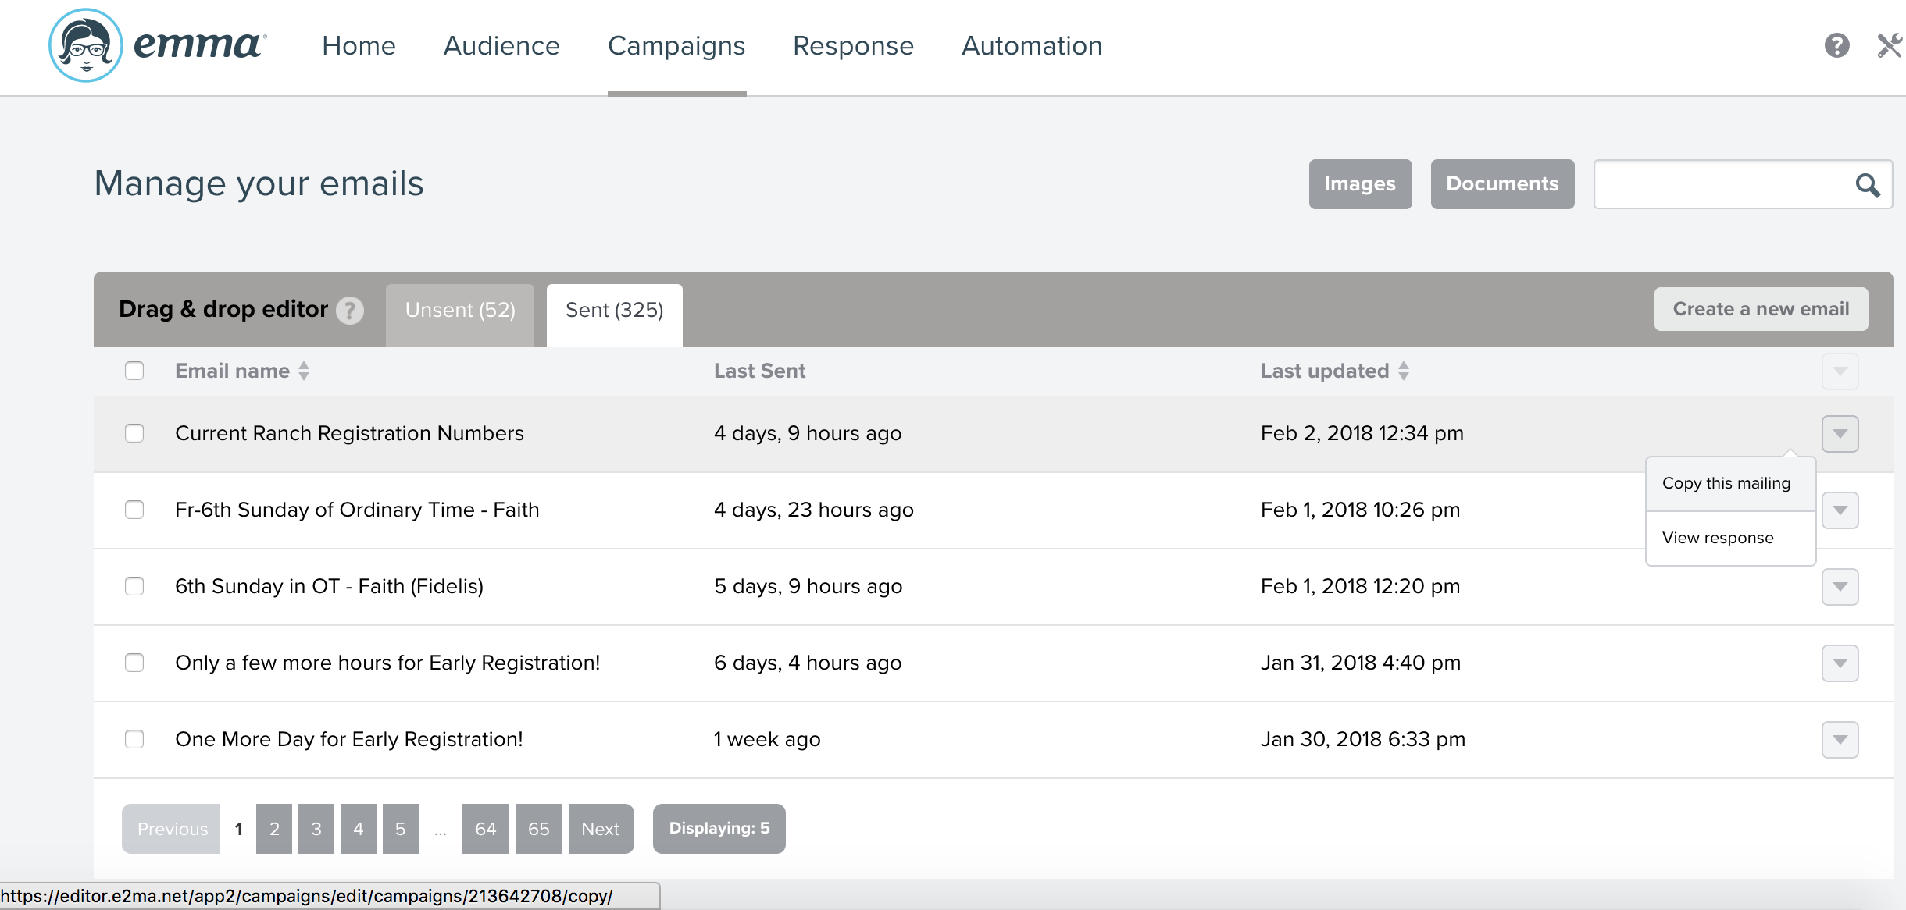
5. Edit the email. Select the textboxes to change written text. Select the images to change images. Textboxes, images, dividers, and other objects in the email can be moved by clicking on them and dragging them to the desired location.
6. N.B. emails will automatically save edit. Click on “revert to” to undo an edit.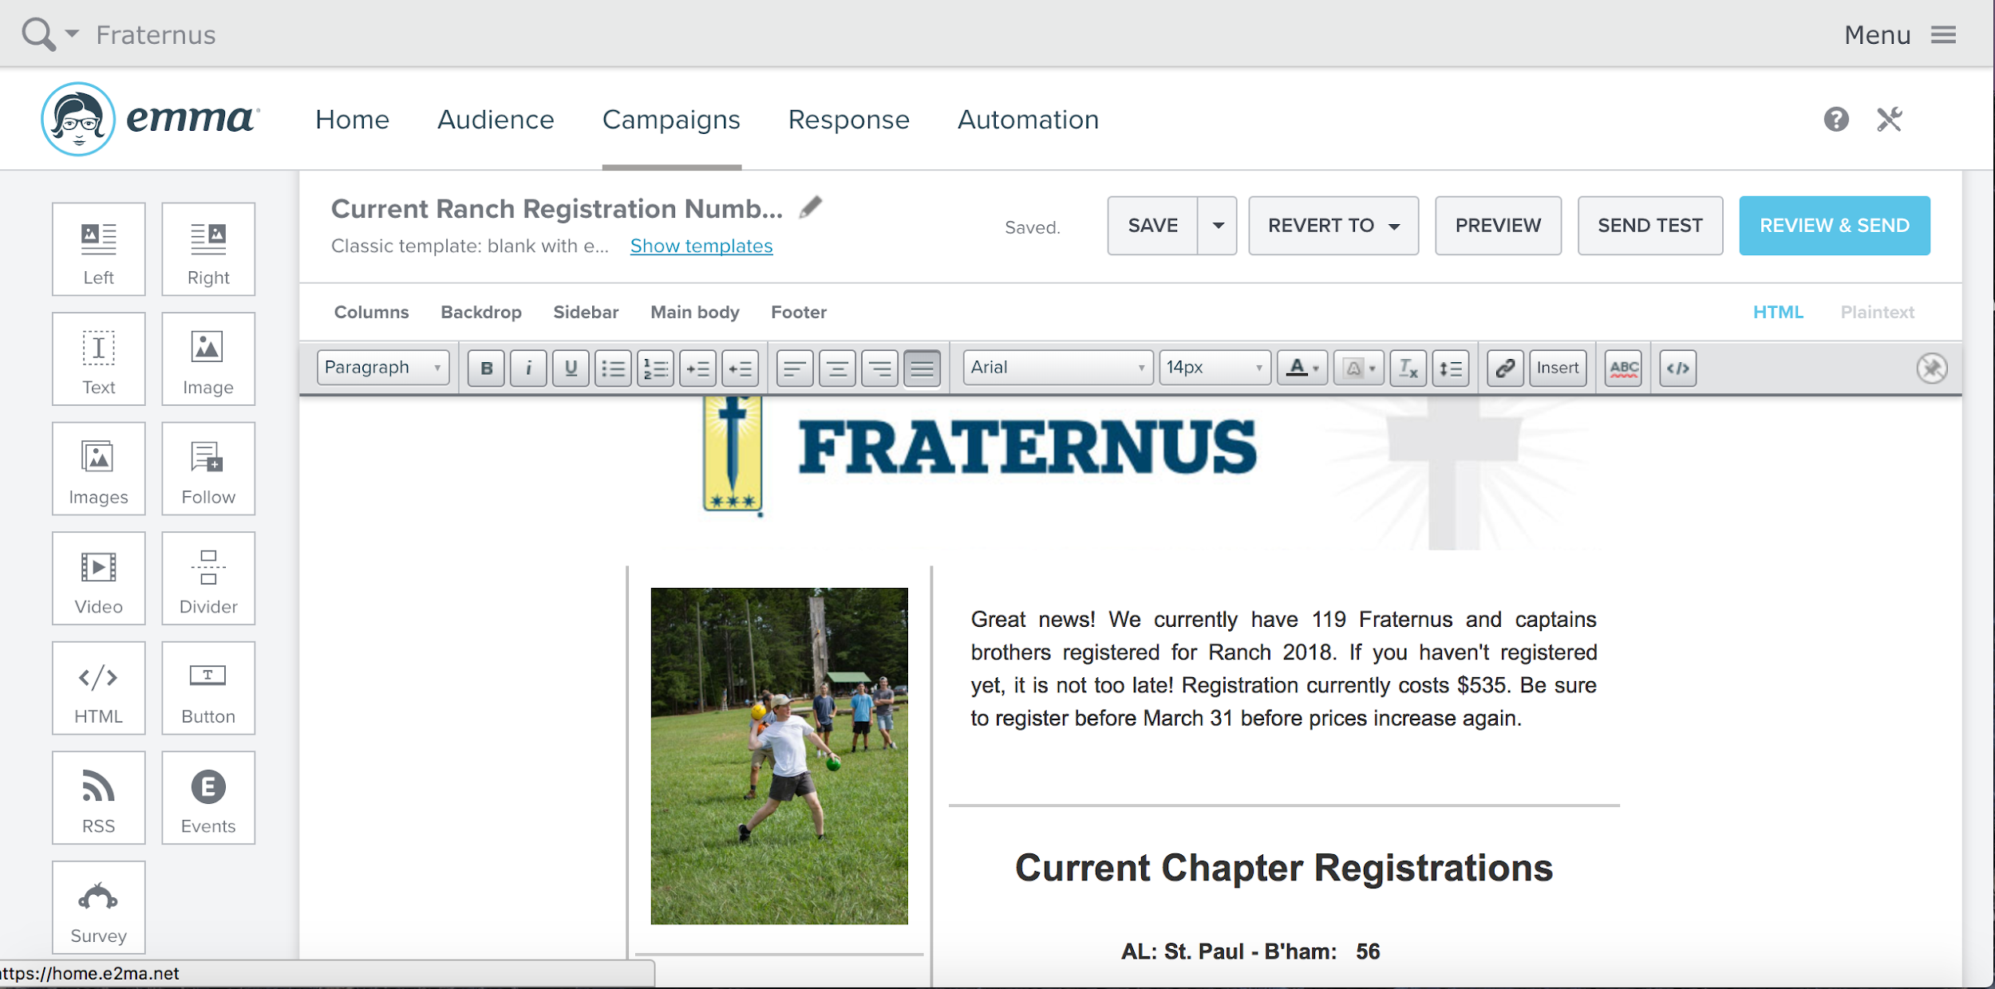
7. Select “Review & Send”. For “choose recipients”, send it to “Ranch Promo Year” e.g. “Ranch Promo 2018”.

Enter a subject line. Then select “Send Now” or “Schedule For Later” in order to send the email.

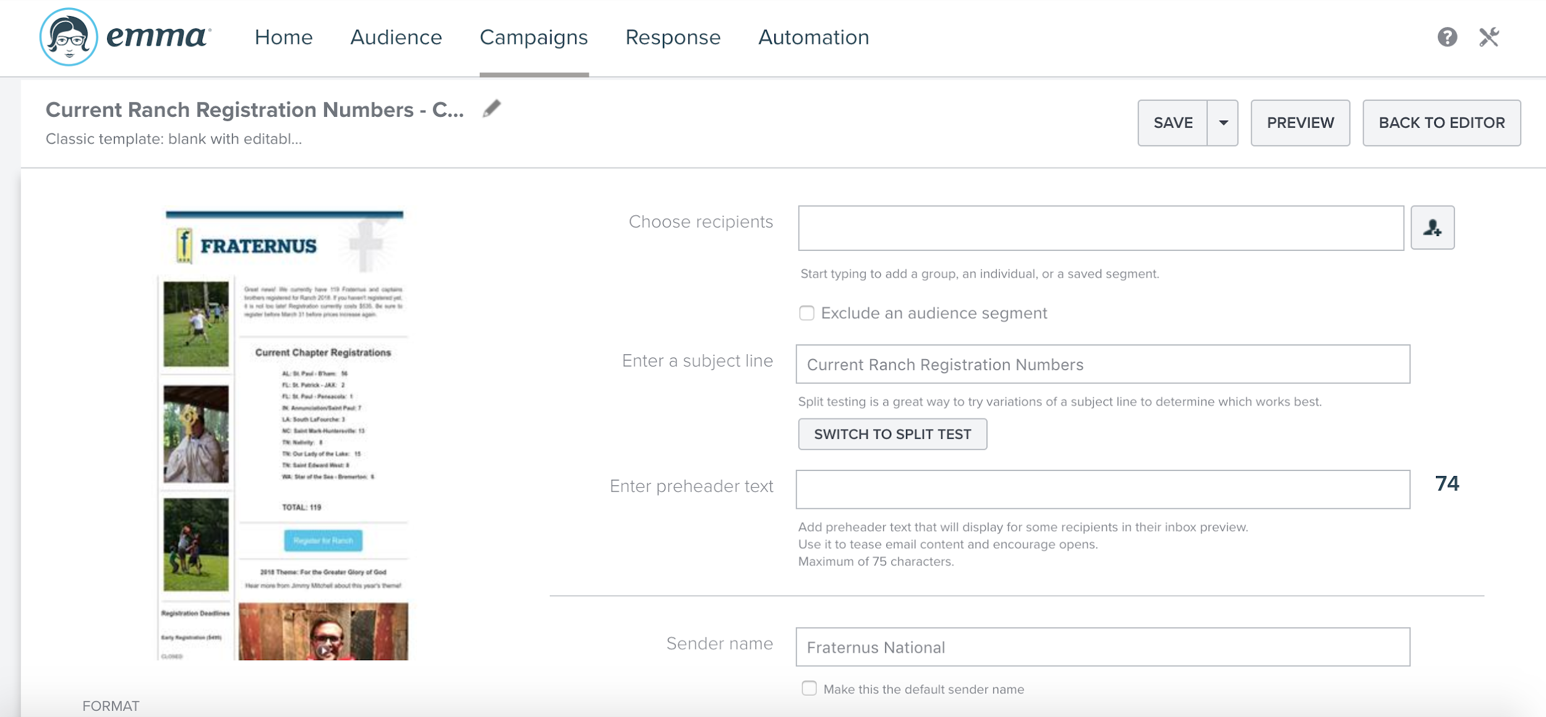

**How to use Vimeo**

1. Login to Vimeo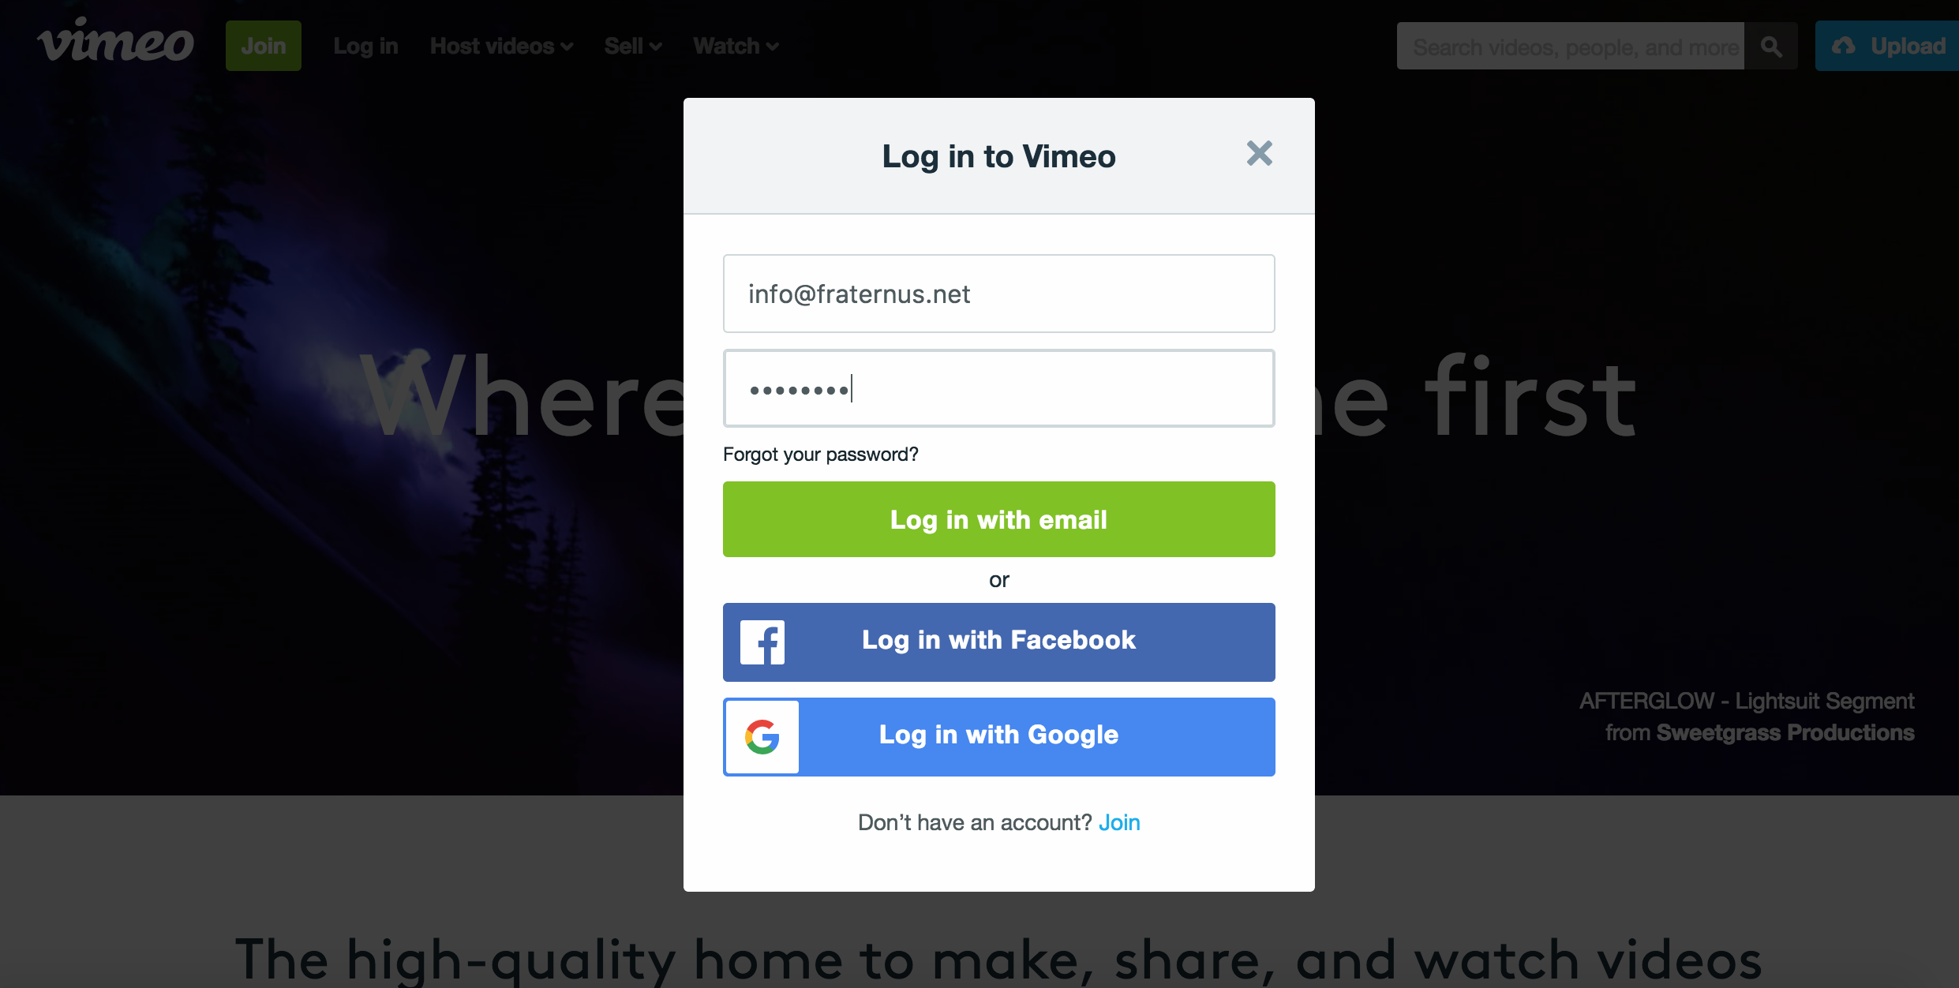
2. Select “Upload” in the top right corner to upload a pre-recorded video file.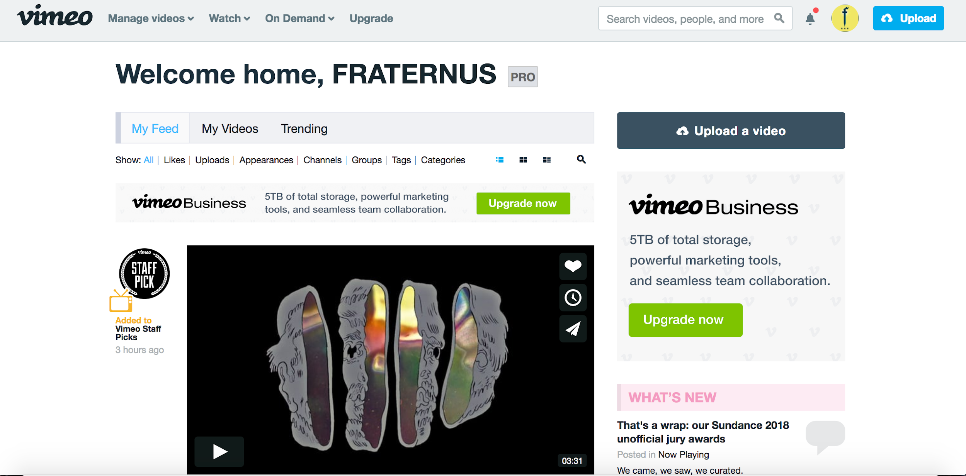
3. Once the video has uploaded, select “Share” to get a shareable link to place in the MyEmma email. Select the video in MyEmma you wish to change and place the correct link.

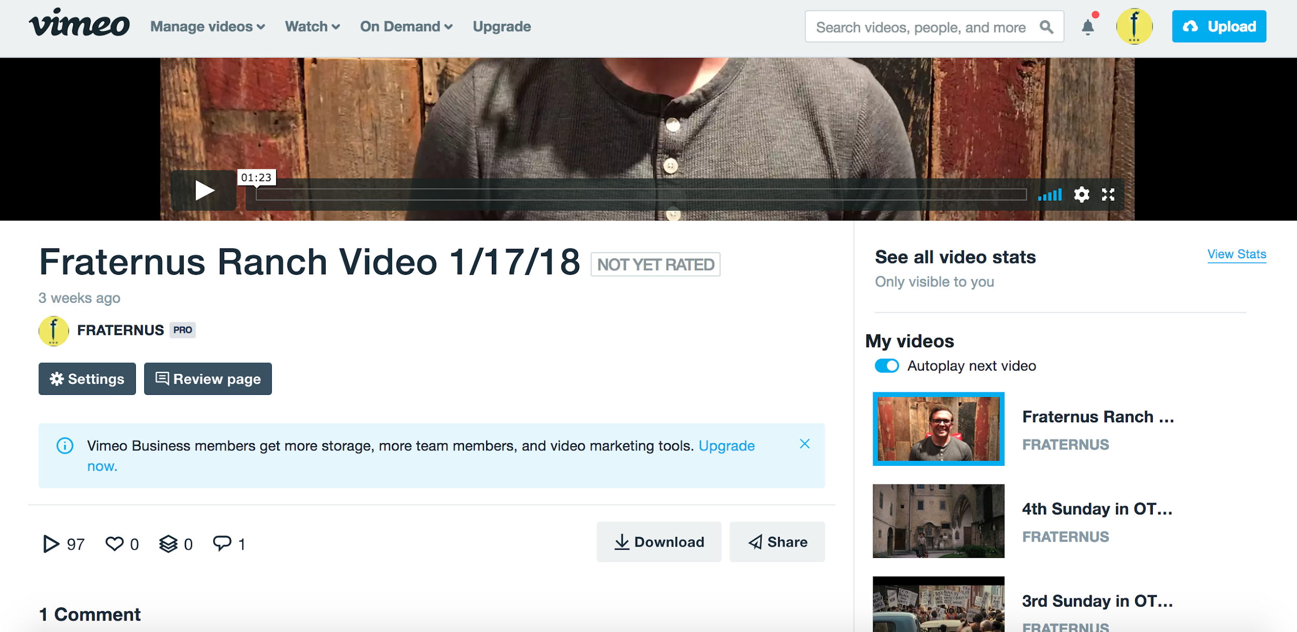

1. **Communicate with Commanders regarding Ranch**

Communicate with the Commanders via email and phone calls. During phone calls, ask about current registration numbers and how they can be supported. Chapters are encouraged to hold a Ranch Information Night to encourage Fraternus Brothers and their parents to register for Ranch.

1. **Determine Theme and Marketing Material 2022 *Fratres in Armis***
2. Past Ranch Themes:

ii. Hero’s Journey Themes

2019: Act I - Pater Noster (Our Father)

2020: Act II - Ecclesia Militans (Church Militant) *Top Secret Until Reveal*

2021: Act III - Ad Ultimum Terrae (To the End of the Earth) *Top Secret*

1. **Find Chaplain and Main King’s Messenger**

The *Main King’s Messenger* 2022 = Jason Craig gives the content talks each evening.

*2022 = Dan Duddy will give the Captain’s Formation talks during the morning session. The seminarians will host the brother formation sessions.

The *Chaplain* 2022 Fr. Rhodes Bolster is the priest responsible for coordinating all liturgies and sacraments while at Ranch. There should ideally be 2-3 additional priests in addition to the chaplain to help with Confessions. Each priest will need to submit a letter of suitability to the diocese in which Ranch is hosted. The past few years Ranch has occurred in the Diocese of Knoxville. In addition to letters of suitability, the diocesan chancellor must be contacted to request permission to repose the Blessed Sacrament while at Ranch.

The Chaplain is responsible for creating the schedule of liturgies of who will celebrate and concelebrate, who will hear Confessions at what times, etc.

The Chaplain should also be consulted in the making of the Ranch breviary (prayer booklet) since he will have input on which feast days will be celebrated throughout Ranch.

The Ranch Content Officer is responsible for being the face of Ranch and gets the brothers and captains excited about being at Ranch. The Ranch Logistics Officer communicates all logistics while making sure the day runs smoothly. The content officer should always be aware of the next time all the Brothers and Captains will be together and communicate any announcements that are needed in between times when everyone is together i.e. where to be next and when, when to begin the fast for Mass, what to bring to evening session, etc.

1. **Ranch Doctor**

The Ranch Doctor 2022 Dr. Eddie Matthews and Dr. Matt Harrison will both be serving to handle general first aid issues. First Aid supplies are a part of the Ranch budget and should be purchased by the Ranch Logistics Officer in conjunction with the Fraternus National Office.

**Beginning Early Spring**

1. Rent Electronics if necessary
   1. Stage lights are helpful to provide adequate lighting during sessions, liturgies, and adoration. We have rented camp equipment for this.
   2. Sound System (soundboard, large speakers), Wireless Microphones have been rented from a gentleman’s company named Seals Production. Kendall Seals is the contact. Walkie Talkies for the past two years have been provided by Jimmy Mitchell and Love Good from Nashville, TN. Walkie Talkies are an effective way to communicate with the spotty cell service of East Tennessee.
   3. Seals Productions provided ALL AV/lighting/stage for Ranch 2019 - they work very well for the large space of Ocoee Ridge
2. First aid supplies
   1. Bandaids, Antiseptic Wipes, Gauze, Tylenol, Advil, Pre-Wrap/Athletic Tape are typically the most needed items. Items from Ranch 2022 are at the Fraternus National Office. We have stocked more items as well.
   2. Always be aware of closest Emergency Room to Ranch. Have directions and phone number ready.
3. Fraternus Ranch Breviary
   1. The Fraternus Ranch Breviary contains all of the Liturgy of the Hours (Morning Prayer, Evening Prayer) and Mass Parts that are used throughout Ranch along with a few additional prayers and blank pages for notes.
      1. Text for the Liturgy of the Hours can be found [here](http://www.ibreviary.com/m2/opzioni.php).
   2. The Ranch breviary is compiled and copied by the content team.
   3. The Ranch breviary should be compiled with the input of the Ranch chaplain, since the priest will have a preference for which feast days to celebrate and Mass parts to use.
   4. Ranch breviaries have been printed in the past by Fraternus National at Staples. There should be enough copies for each attendee to have one.

**After Registration is Complete**

1. Assign Activities to Ranch Attendees
   1. Assigning of activities depends on the number of activities and the suggested number of participants for each activity. Ocoee ridge camp offers 5 activities in rotations. 1) Paintball, 2) Wave pool, 3) High ropes, 4) Adventure race, 5) Covered pavilion. Around 80 is the suggested number of people at each activity. 2022 we had 500 campers where we had to split them into 6 different groups A, B, C, D, E, and F. Each camper will get to do each activity at least once and wave pool twice.
2. Assign Cabins
   1. We had 30 bunks to fill with each holding 16 brothers. 2022 we are busting at the seems and only had two beds open. We used one of the 30 for the national team bunk and it was packed as well.
   2. Priests require separate housing from the lay faithful. Seminarians do not require separate housing, but historically they have preferred separate accommodations. 2022 we had Cabin 1 which sleeps 18 and we were able to put all priests and seminarians in that cabin. We have two national staying off site and one family staying in Hall’s Cabin just down the hill.
   3. The Host Family requires separate housing along with any families from the Fraternus National Office. Jason Craig and his family stay in Cabin 3 which sleeps 10.
3. Assign Rafting Times

**(i) Each camper needs to be assigned a rafting time. This year we had 8 time slots to put 437 rafters. Rafters must be 12 years of age and the time of rafting. Each camper indicated whether they were going to raft or not. *New 2022.**

1. Assign Squads

**(i) Each camper needs to be assigned a squad for squad time before arriving at Ranch. Campers and captains are specifically picked from across the country and other chapters to get to know the brotherhood on a more national level. Around 6 brothers and 3 captains per squad. Squad names are listed as 6.1 or 6.2 meaning 6th grade squad one or squad two.**

1. Assign Warrior Dash Groups

**(i) Each camper needs to be assigned to a warrior dash group. This is easily done by having all of the .1 or .2 from squads join together to make the warrior dash group. This ensures that the warrior dash group will have a mix of all ages and chapters from around the country.**

1. Order T-shirts
   1. As soon as final numbers are determined, the registration information of each attendee is used to determine how many t-shirts to purchase. Be sure to include priests, hosts, seminarians, Fraternus National in your count even though they may not be officially registered. A few extras of each size are typically ordered. Printed lists for each chapter is necessary for t-shirt distribution.
2. Ask Commanders to Bring Snacks for their chapter
   1. Snacks are for Chapter Chat which is a chance for chapters to gather and share how the Lord has been working in and through the Brothers and Captains throughout Ranch. The best Chapter Chats are those in which the Brothers do the majority of the talking and sharing. Chapter Chat, like Squad Time, should not be a second King’s Message.

Ranch Priorities

___________________________________________________

1. A Typical Day at Ranch (What to Do and When)

**Skeleton Schedule**

7-8a Holy Hour and Confession in Main Space

8-9a Mass

9-9:35a Breakfast

9:45-10:30 Brother formation / Captain’s formation

10:30-12p Prayer/Adoration/Reflection/Reading

12:00p Lunch

1:00-5p Activity Rotations (2/day)

6p Dinner

7p Comp Time

7:45p Kings Message (Movie to Talk) and 30 min talk

8:30p Squad Time

9p Compline

9:15p Chapter Chat

10:15p In-Cabin

11p Lights Out

1. Arrival
   1. Captains check-in at the registration tent below bunkhouse 2. They will turn in all waivers and receive their chapter’s packet of captain printed schedules, rotations, and group lists.
   2. Signs should be posted on the bunkhouse doors sating the buddy system, bathroom expectations, and bunk rule.
   3. Captains should be told the time of the first Captain’s Meeting. Captains meetings typically occur every day at the beginning of dinner, except for the first meeting. During the meetings, the schedule is reviewed and announcements are made.
      1. The first Captains Meeting is used to review rules, explain the layout of the camp, to review the schedule up until the Captains Meeting the following day, and to kick off the week with prayer in mind. *It should be explained that the best Squad Times are those in which the Captains do little to no talking and simply facilitate the discussion and sharing of the Brothers by asking questions.*
2. Signature Ranch Events
   1. Eucharistic Procession
      1. Typically occurs after the opening Mass of Ranch. Procession passes most cabins and returns back to the location where Mass was held. In past years, the procession has taken about 30-35 minutes.
   2. Warrior Dash
      1. Occurs the morning of the final full day of Ranch in place of activities. The Warrior Dash begins in the assembly hall for groups to get their starting positions and it is a shotgun start and exactly 10:20am.
      2. The points for each team is kept by a Captain at each station. Teams will work to score points at each warrior dash location. The team with the most points at the end wins. Announcement will be made later on in the evening.
      3. Warrior Dash stations 2022. Basketball toss, frisbee toss, sand sock toss, buddy carry challenge, tennis ball toss, bear crawl, the maze at low ropes, and burpee challenge.

All Night Adoration

* + 1. Takes place the final night before Ranch ends. The Blessed Sacrament is exposed before Compline and is reposed before Mass on the final morning of Ranch
    2. A sign-up sheet is needed to ensure someone is present throughout the night. It is best to have at least 4-5 signed up for each hour in case someone falls asleep.
  1. Rafting
     1. At Ocoee Ridge 2022, rafting was coordinated with Adventures Unlimited. This is under the Ranch Logistics Officer duties. Fraternus was split up into 8 different time groups. Each group has approx. 56 people.
     2. Beware of the age restrictions for certain sections of the river. At Adventures Unlimited, the age restriction is 12 years and older. The younger ones will play at the covered pavilion.

1. Additional Events in Schedule
   1. Letter Writing for Bosco Society
      1. Fraternus National provides the names, addresses, letters, and postcards for each chapter. Three groups letter white on Friday while the other three groups letter write on Saturday.
      2. Fraternus national will give instructions on what to do.
2. Sacraments
   1. Typically the Confessions are heard during morning Holy Hour (7-8a) and during Chapter Chat (9:15-10p). Locations to hear Confession are in the assembly hall.
   2. Liturgical items (altar, ambo, monstrance, sacred vessels, vestments and cassocks, hosts and wine, cross and candles, incense) should coordinated with the chaplain to see who will provide what.
   3. The Seminarians present at Ranch usually serve as sacristans and lead the Liturgy of the Hours. Ask the seminarians to bring their own cassocks.
3. Content
   1. The evening session is the main content for Ranch. It typically entails a movie clip followed by a prayer lead by the Captains over the host who will give the King’s Message for the night.
   2. The morning brother/captain formation is the morning content session and typically is a chance for lectio divina and other forms of prayer for the Fraternus Brothers and a talk on fatherhood and family for the Captains.
   3. Since the Brothers and Captains are in separate places for the formation, it is important that formation wraps up in a timely fashion to ensure that activities for the day start on time.
4. Squad Time
   1. Squad Time is led by Captains. Experienced Captains should be asked to lead sqaud times. Two Captains at least are needed per squad.
   2. Squads are divided by grade. Typically there are 4-5 squads of 8-10 Brothers for the middle school grades and 2-3 squads of 8-10 Brothers for the high school grades. Captain assignments and squad assignments are done ahead of time by the Ranch Logistics Officer.
   3. *It should be explained that the best Squad Times are those in which the Captains do little to no talking and simply facilitate the discussion and sharing of the Brothers by asking questions.*

VIII. Schedule Flexibility

1. Unexpected changes and conflicts are inevitable at Ranch. As much as one plans, the Ranch Officers should be prepared to adjust the schedule of daily activities and events.

**Post-Ranch Priorities**

___________________________________________________

1. Surveys/ SWOT Analysis
   1. Surveys should be emailed out within one week from the conclusion of Ranch and used to make appropriate changes for the following Ranch.
   2. A Ranch Review Conference Call should take place with the Fraternus Ranch Officers and Fraternus National
2. Book Ranch 2023 Dates